COMP 353 : Assignment #1

Presented to :

Dr. Khaled Jababo

Presented by :

Jordan Hubscher, ID : 27019696

Brandon Mendez, ID : 27003606

Anthony Mendez, ID : 26998380

**Question 1**

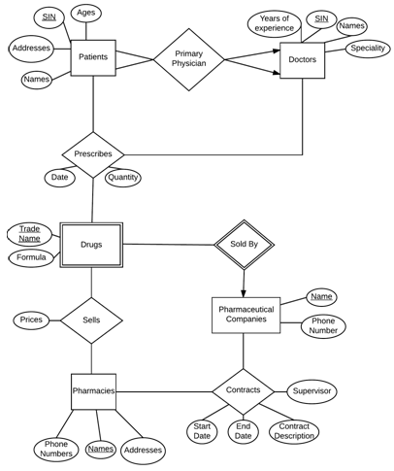

3.

Patients(sin, Names, Addresses, Ages)

Doctors(sin, Names, Speciality, Years_of_Experience)

Primary Physician(D.sin, P.sin)

Prescribes(Date, Quantity, P.sin, D.sin, Trade_Name, PC.names)

Drugs(Trade_Name, PC.name*, Formula)

Sells(Prices, Trade Name, PC.names, P.names)

Pharmacies(Names, Phone_Numbers, Addresses)

Pharmaceutical Companies(Name, Phone_Number)

Contracts(Supervisor, start_date, end_date, contract_description, P.names, PC.names)

|  |
| --- |
| **Legend** |
| Underlined: Primary Key |
| *: Foreign Key |
| D: Doctors |
| P: Pharmacies |
| PC: Pharmaceutical Company |

4.

Prices would become an attribute of the Drugs entity and the relationship Sells would no longer have to be converted to a relational table.

**Question 2**

1. SELECT * FROM Doctor WHERE specialization = ‘Eye Surgery’;
2. SELECT pname, dname, date, city FROM (Patient JOIN Consults ON Patient.pid = Consults.pid) JOIN (Doctor JOIN Consults ON Doctor.did = Consults.did) ON Patient.pid = Consults.pid WHERE date = ‘02-15-2016’ AND city = ‘Laval’;
3. SELECT pname, dname, date FROM Consults JOIN Patient ON Consults.pid = Patient.pid WHERE dname = ’Dr. Robinson’;

1. SELECT did, dname, cid, specialization FROM Doctor JOIN (Works_in JOIN Clinic ON Works_in.cid = Clinic.cid) ON Doctor.did = Works_in.did WHERE city = ‘Laval’;
2. SELECT pname FROM Patient JOIN Consults ON Patient.pid = Consults.pid WHERE illness = ‘Heart Disease’;